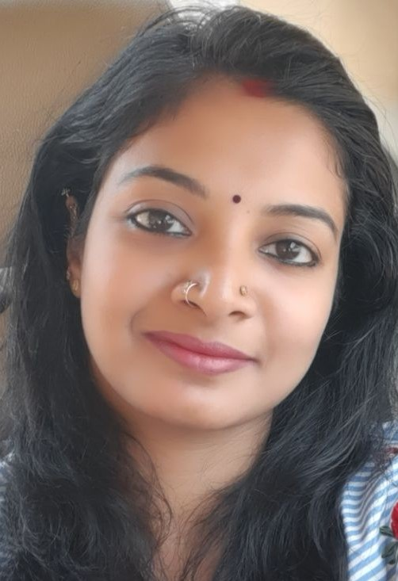
SHRADDHA KAPIL,
#173, SAI TEMPLE ROAD, SAI NAGAR 1ST PHASE,2ND CROSS
CHIKKABETTAHALLI, BANGALORE 560097
KARNATAKA, INDIA.

Mobile : 91-7676968593
E-Mail : shraddhakapil31@gmail.com
-----------------------------------------------------------------------------------------------
Experience Summary

I’m a self-motivated, professional with an overall experience of 3 years in Research and development, and professional educator, with diverse exposure in analysis and people management. I would like to work in an environment, which provides me an opportunity to enrich my knowledge and to serve the organization to meet its expectations, being open to ideas, making learning a continuous process.

Educational Qualifications

- Masters in Applied Zoology from Mangalore University 2012

- Bachelor in Biotechnology, Chemistry and Zoology (Triple main) from Alva’s College, under Mangalore University 2010

Additional Qualifications

- Secured First Rank in M.Sc. from Mangalore University (2012)
- Was eligible for INSPIRE Fellowship (2013)

Strengths

- Enthusiastic and passionate towards Teaching, Research and Life
- Strong interpersonal skills, ability to work smoothly and cooperatively in groups
- Strong motivation to grasp new techniques quickly and effectively
- Ability to accept challenging projects and to execute them effectively
- Good communication skills
- Excellent team member.

Workshops / Conference Participations

- National Seminar on Recent Trends and Future Prospects in Biotechnology, Alva’s College (2009)
- Workshop on Ecology, Identification and Conservation of Butterflies- National Environment Awareness Campaign (2010-11)
- Workshop of Karnataka Science and Technology Academy (KSTA) (Jan 2012)
- Was a participant and member of the organizing committee of KSTA Special Lecture Series held at Mangalore University. (Sept. 2013)
- Was a member of Natural History Association of Applied Zoology Department, Mangalore University (2014).

Work Experience

- Worked in ADVINUS Therapeutics Ltd., A TATA Enterprise as Associate Research Scientist (Trainee), in Safety Assessment Department, Bangalore
(June 2012-December 2012)
- Worked as Project Assistant in Central Animal Facility in Indian Institute of Science, Bangalore. (Jan 2013-June 2013)
- Worked as Guest Lecturer (Full time) in Department of Applied Zoology, Mangalore University, Konaje for M. Sc. (Sep 2013- March 2014)
- Worked as Part time lecturer for PUC, Biology (CBSE) in Vishwamangala Education Trust, Konaje, Mangalore (Sep 2013- March 2014)
- Worked as Lecturer in Biology (CBSE) in Alva’s Pre-University College, Moodbidri, Mangalore (June 2014-September 2014)
- Worked in Singh Tutorials, Bangalore. (May-2016 – March-2020) as a part time tutor.

Hobbies

Playing flute, listening music, reading, drawing, singing, travelling, crafts, presenting and organizing seminars and workshops.

Languages Known

To Write: English, Malayalam, Hindi, Kannada.
To Speak: English, Malayalam, Kannada, Tamil and Hindi.

Declaration

I hereby declare that the above information is true to the best of my knowledge.

(Shraddha Kapil
alias Jerin Sara Jaise)

